**TEST MANAGEMENT SYSTEM**

**A MINI PROJECT REPORT**

*Submitted by:*

**Group No: G24/T4**

Jaikirat Dev (2210990428)

Jaivardhan Khanna (2210990429)

Janvi Jain (2210990430)

Janvi Sethi (2210990431)

***in partial fulfillment for the award of the degree of***

**BACHELOR OF ENGINEERING**

*in*

COMPUTER SCIENCE & ENGINEERING



**CHITKARA UNIVERSITY**

**CHANDIGARH-PATIALA NATIONAL HIGHWAY**

**RAJPURA (PATIALA) PUNJAB-140401 (INDIA)**

May,2023

Group/Team no: G24/T4

Index

|  |  |  |
| --- | --- | --- |
| **Serial No.** | **Subject** | **Page No.** |
| 1. | Abstract & Introduction | 1 |
| 2. | Problem Statement & Technical Details | 2 |
| 3. | Key Features & Advantages | 3 |
| 4. | Project Highlights | 4-6 |
| 5. | Conclusion | 7 |
| 6. | References | 7 |

**Abstract**

Online examination system is a web-based examination system where examinations are given online by using the internet on a computer system. The main goal of this online examination system is to effectively evaluate the student thoroughly through a totally automated system that not only reduces the required time but also obtain fast and accurate results. The main objective of our software is to efficiently evaluate the candidate thoroughly through a fully automated system there is no need of paper and pen. The user can write exam without going to the exam centre.

**Introduction**

The name of our site is ‘‘*Padha.io*’’ and it has been deployed using HTML ,CSS , JavaScript and PHP .Our site enables a student/person to to be able to check the theoretical understanding of the concepts of the subjects he/she has chosen .And by doing so , a person can check if he/she has fully grasped the concepts or still needs to practice more .After completing the test ,a person can click on the submit button and then can be redirected to a page that showcases his/her marks obtained.

**1**

**Problem Statement**

A test management portal is to be designed using HTML, CSS and JavaScript. It is like a portal consisting of MCQs that can be based upon the subject the applicant chooses and based upon the right/wrong answers ,a score sheet with detail marks and information about the applicant can be maintained.

**Technical Details**

Building this system is technically feasible. The hardware and software needed are all available, it not difficult to get them. Brief I can say the necessary resources needed for the development and maintenance of the system are available. We are going to use HTML, CSS and JavaScript programming language to complete this project.

**2**

**Key Features**

* **Front page** of the examination website is shown.
* A **login page** is formed for students to enter their required details for taking the exam.
* Student will be asked to enter a test subject before they can proceed further.
* After entering the subject ,students will be redirected to an *Instructions* page.
* After clicking the “*I Agree”* button ,a **MCQ based test** will be generated.
* Student can select options for the correct answer.
* **Time**rwill be shown on the top of the test page.
* **Result page** will be generated in the end.

**Advantages**

The advantages of a test management system are :

* It helps a candidate in grasping the subject .
* It can increase the versatility of the candidate’s knowledge by allowing him/her to opt and give test for different subjects.
* It can help a candidate improve from his/her mistakes.

**3**

Project Highlights

**Code Snippets**

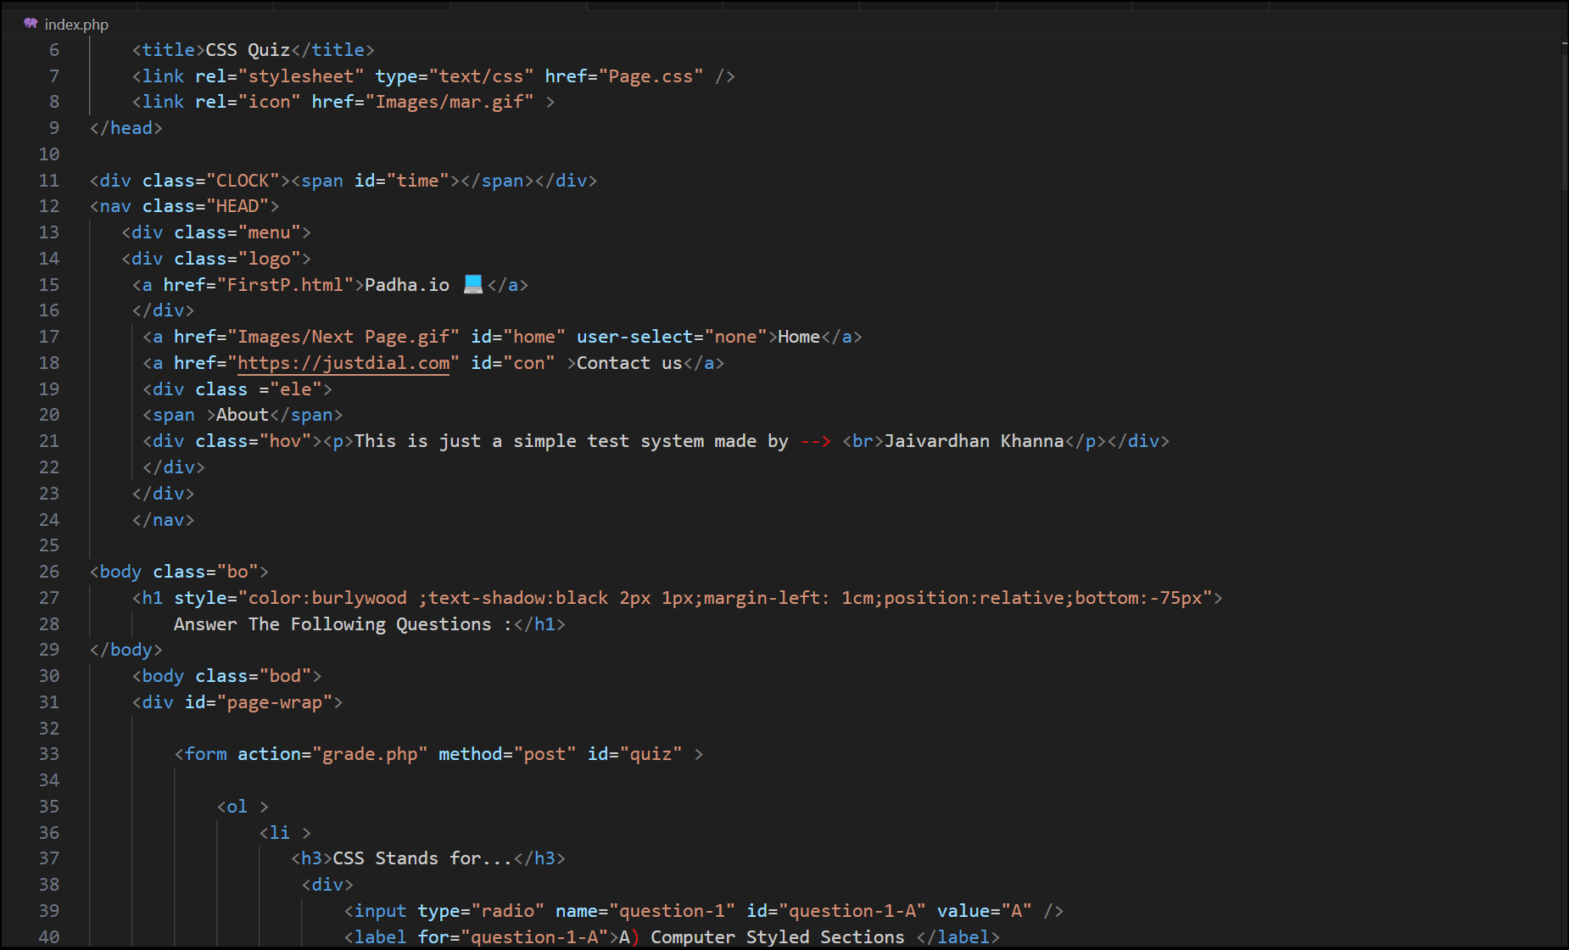

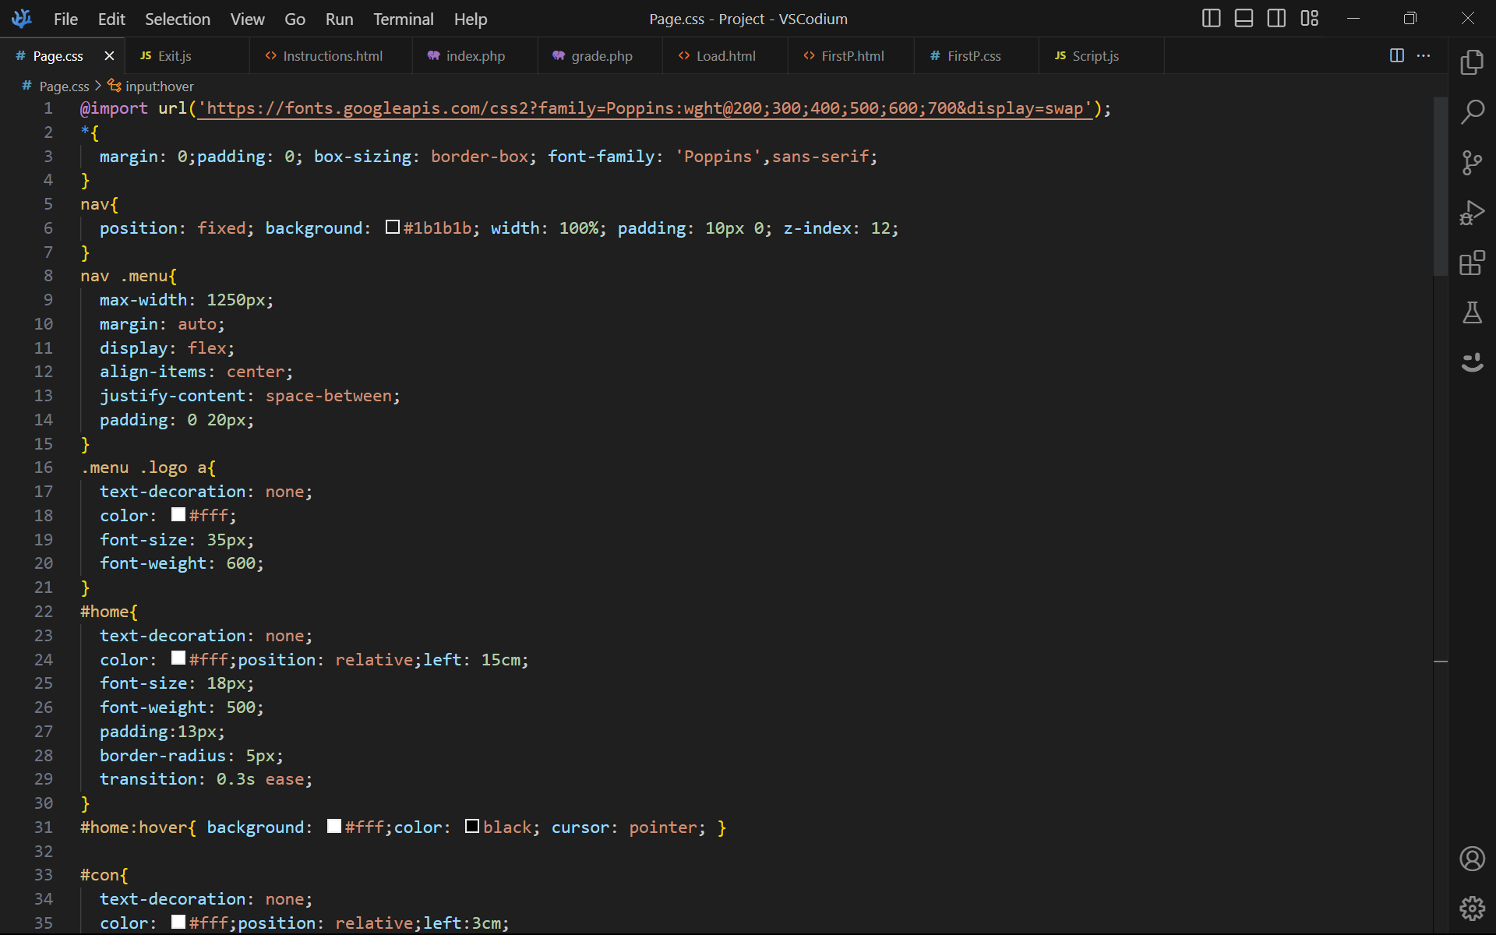

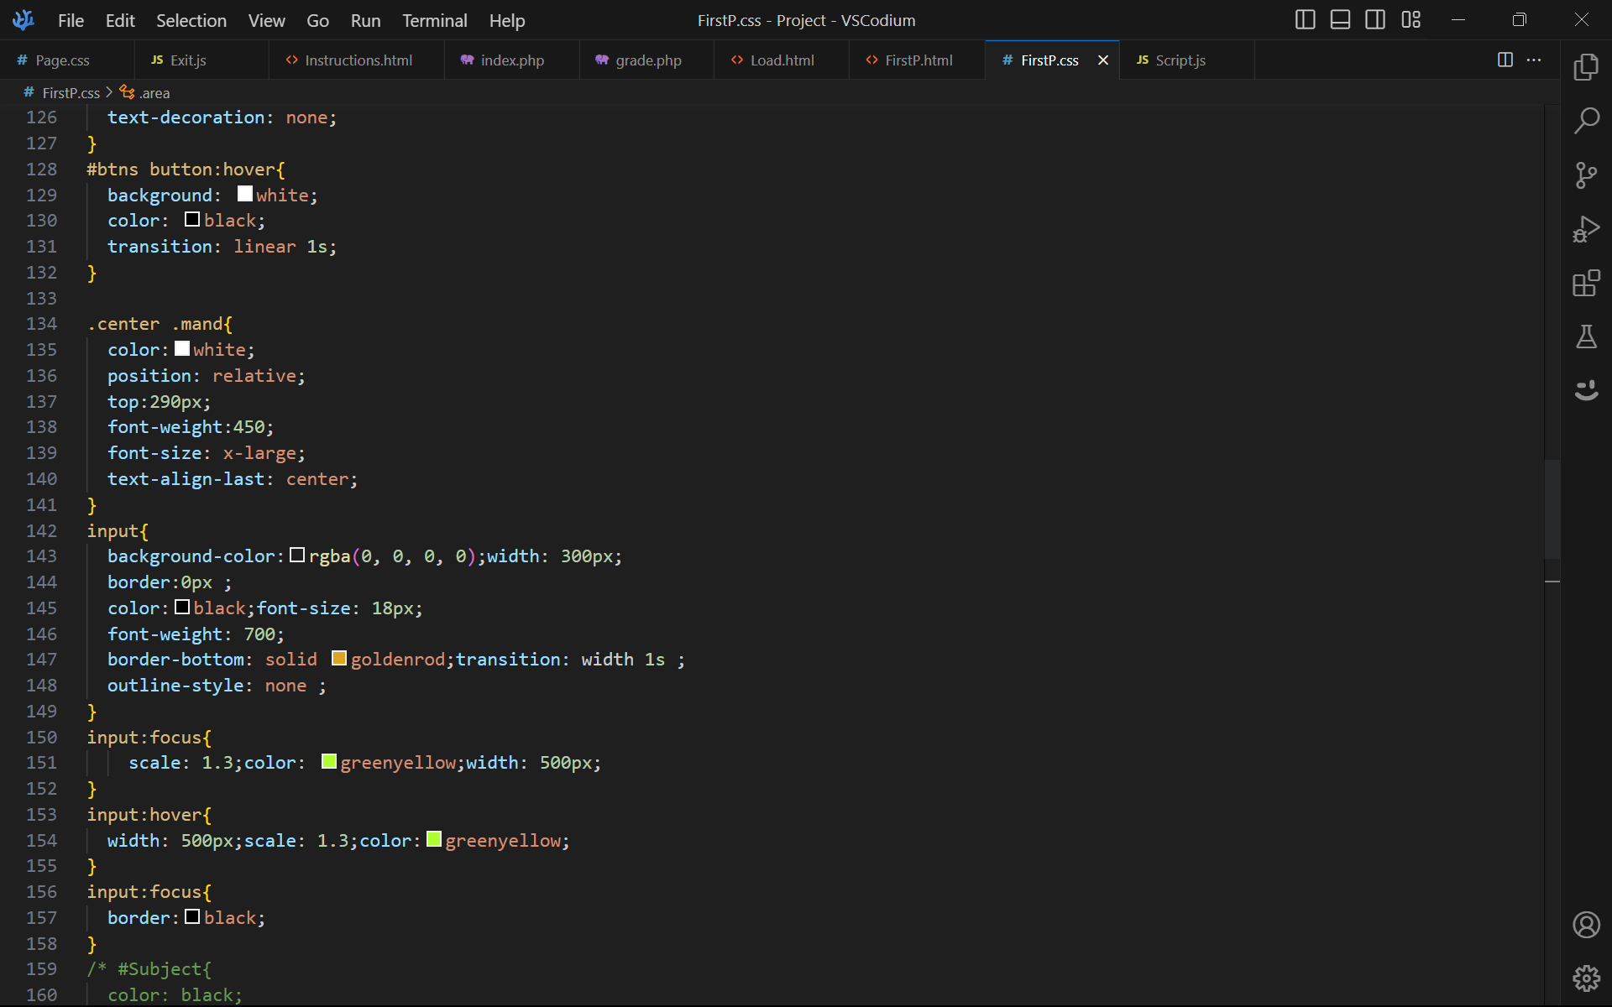

**4**

**Images of Website**

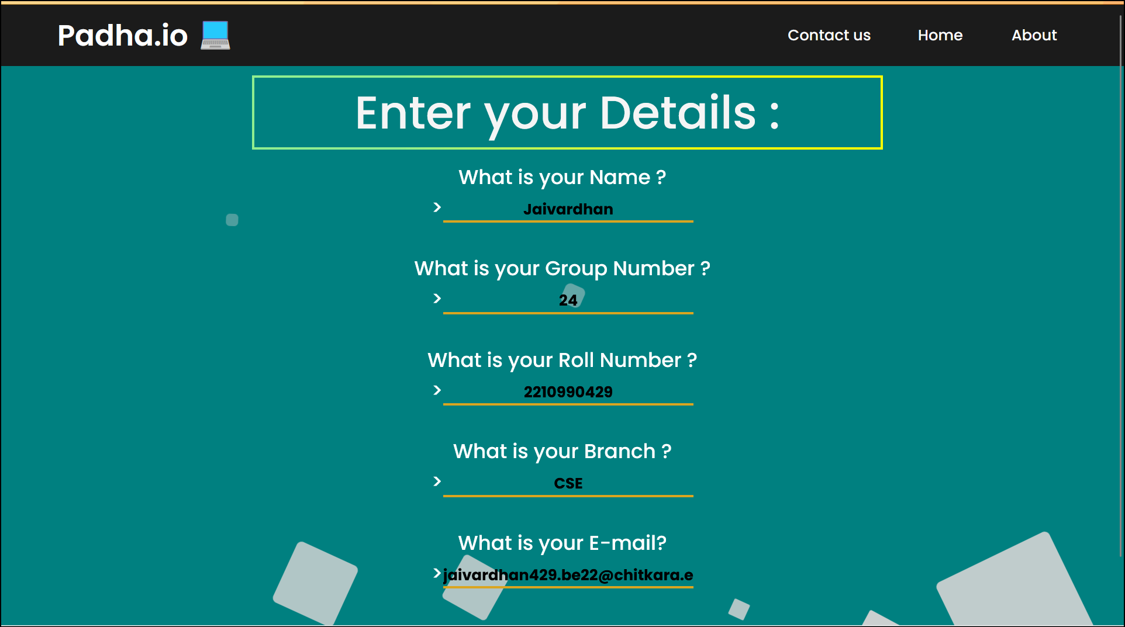

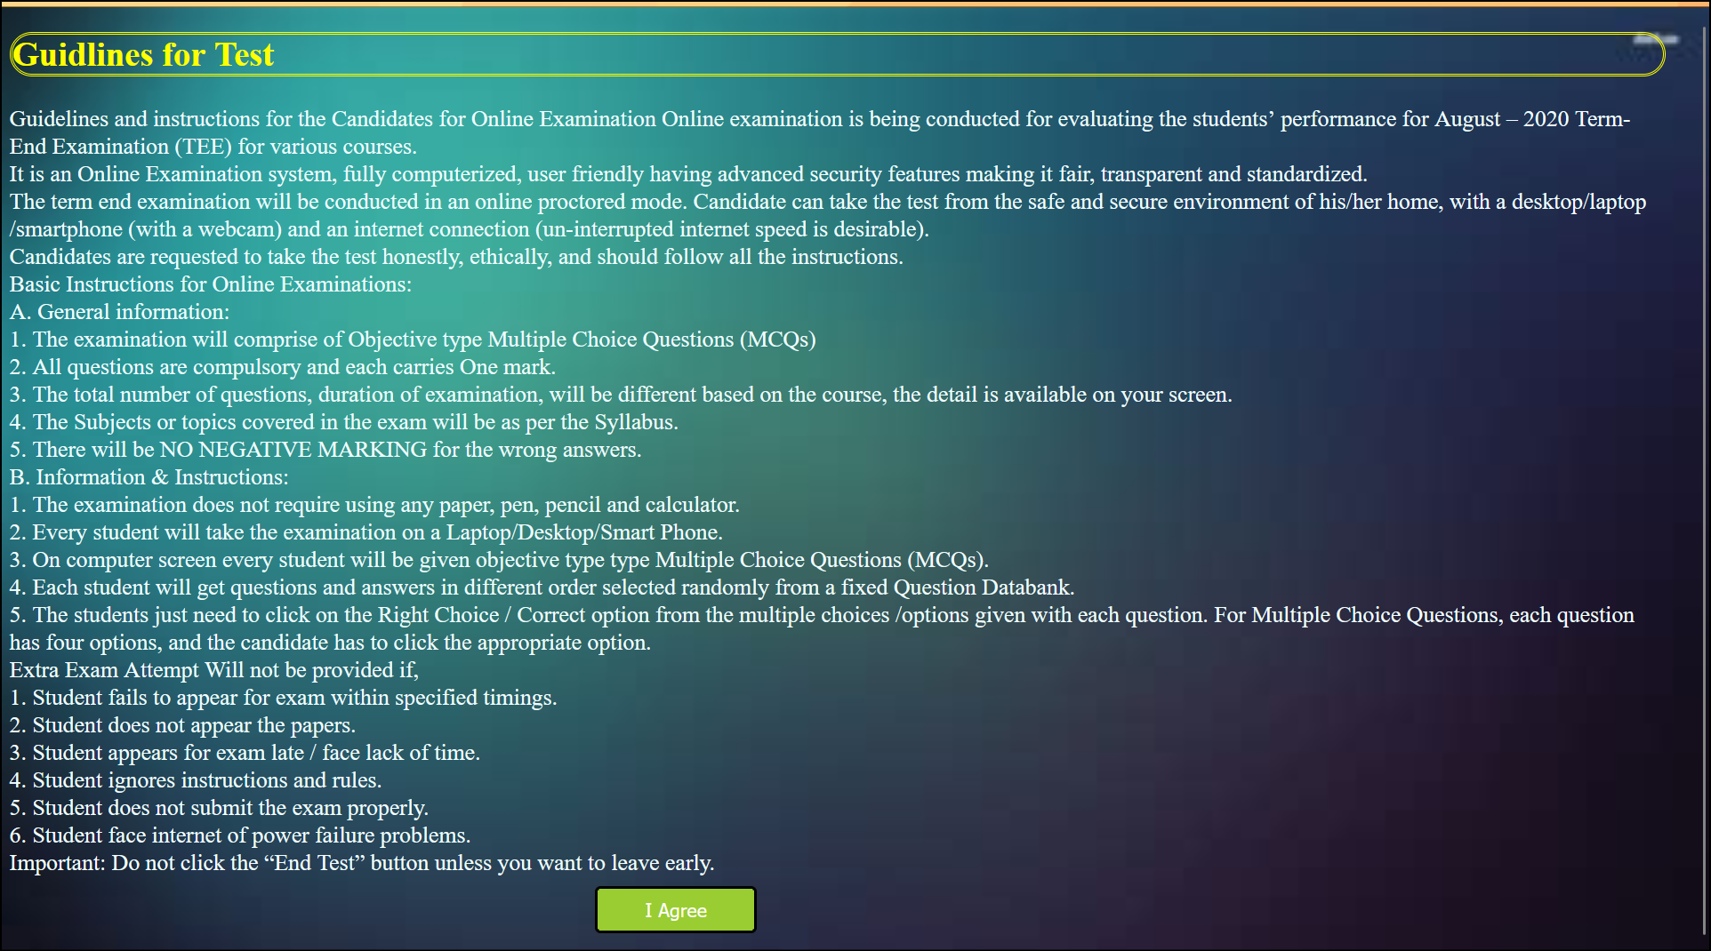

**5**

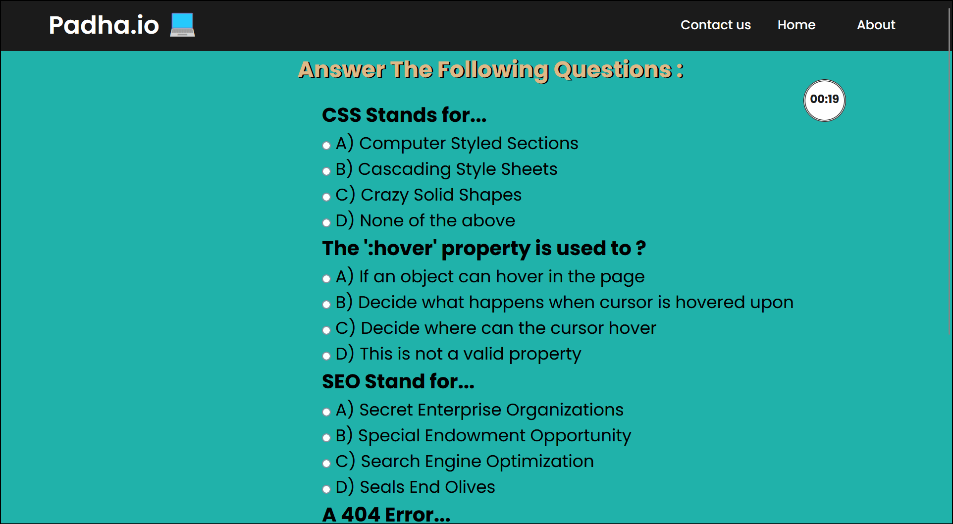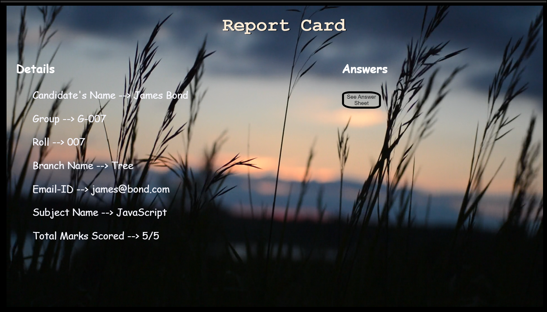

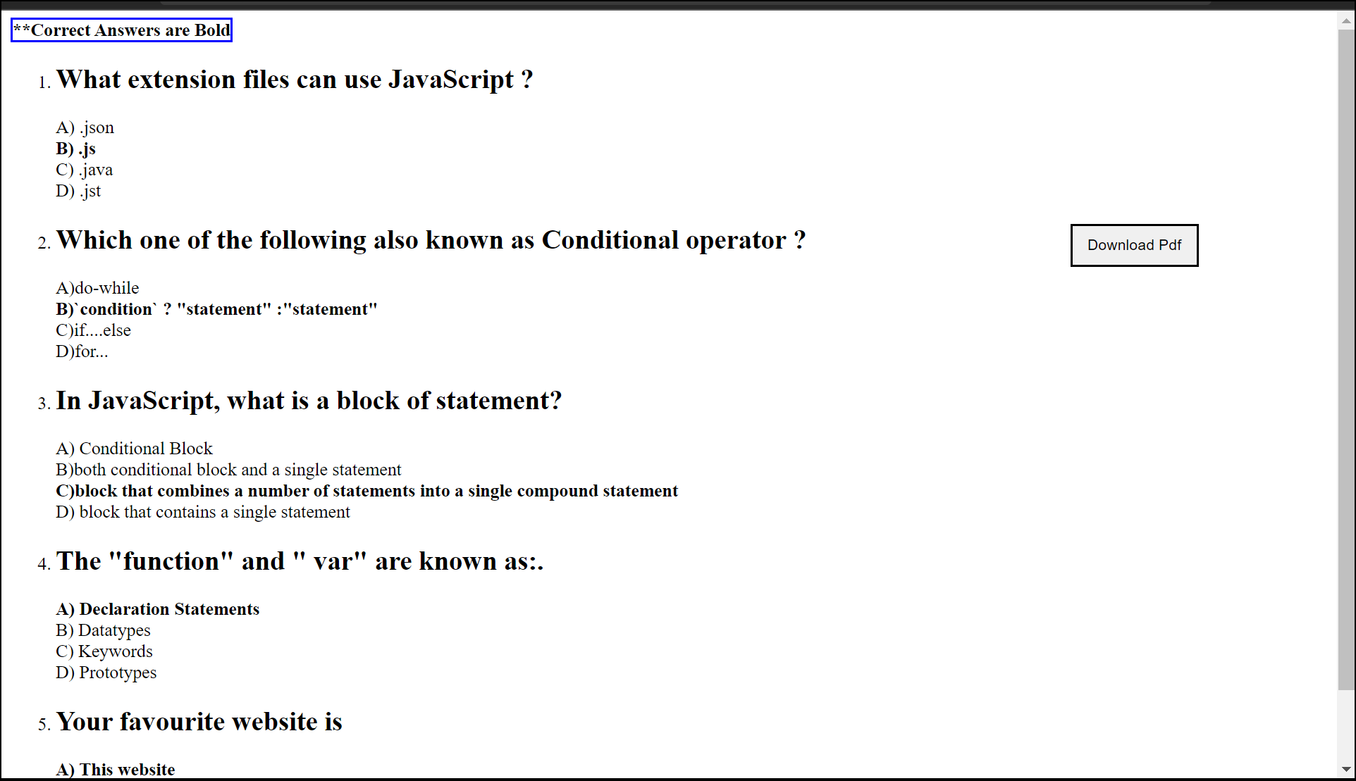

**6**

**Conclusion**

* With the completion of this project we conclude that it has achieved its purpose.
* The whole project provides a base for students to take their exam using the web site.
* The system is developed using HTML, CSS ,PHP and JavaScript programming language.
* Online examination is better as compared to paper-based exam.
* The automated system helps students and lecturers to save time and makes the process faster.
* It is also more environmental .

**References used:**

* [https://www.w3schools.com](https://www.w3schools.com/)
* [https://Mozilla.org.com](https://mozilla.org.com/)
* [https://practice.geeksforgeeks.org](https://practice.geeksforgeeks.org/)
* [https://codescholl.com](https://codescholl.com/)

**Books**[**:**](https://www.w3schools.com/)

* ‘*Web Enabled Commercial Application Development using HTML, JavaScript, DHTML and PHP*’ by Ivan Bayross, 4th Edition, BPB Publications.
* ‘*The Complete Reference HTML & XHTML*’ by Thomas Powell, 5th Edition, Tata McGraw-Hill Company Limited.

**7**